L03 Participation Assignment – Conditionals

Background
Explore Python using conditionals and loop stuctures

Procedure
Review the attached .py files and answer the following questions.

- Open the file L03_average_exam.py. Note that line #12 comments indicate a line of code is missing.
  - What line of code could you add to check that moreGrades is equivalent to ‘Y’?
while moreGrades == ‘Y’:
- Open the file L03_salary_average.py. Try to run.
  - Conditional structures require proper indentation to work. Line #13 comments indicates the following lines do not have proper indentation. Correct the indentation.
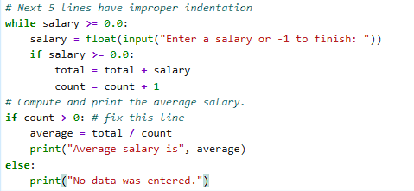
  - Line 21 is has an incorrect keyword. Erase ‘fixme’ and replace with the correct keyword to test the condition of ‘count’ . Paste the corrected code here:
if count > 0:

- Submit this word document to Canvas.

